Vision and Scope Document

for

< usedbooks.com >

Version 1.2 approved

Prepared by <雷艺湧>

<软工中外一班>

<6.30>

Table of Contents

Table of Contents ii

Revision History ii

1. Business Requirements 1

1.1. Background 1

1.2. Business Opportunity 1

1.3. Business Objectives 1

1.4. Success Metrics 1

1.5. Vision Statement 1

1.6. Business Risks 1

1.7. Business Assumptions and Dependencies 2

2. Scope and Limitations 2

2.1. Major Features 2

2.2. Scope of Initial Release 2

2.3. Scope of Subsequent Releases 2

2.4. Limitations and Exclusions 2

3. Business Context 2

3.1. Stakeholder Profiles 2

3.2. Project Priorities 3

3.3. Deployment Considerations 4

Revision History

|  |  |  |  |
| --- | --- | --- | --- |
| **Name** | **Date** | **Reason For Changes** | **Version** |
| 雷艺湧 | 6.24 | 完成第一版 | 1.0 |
| 雷艺湧 | 6.26 | 补充细节和调研数据图片 | 1.1 |
| 雷艺湧 | 6.30 | 补充用例图 | 1.2 |

# Business Requirements

## Background

This project aims to develop a website called "usedbooks.com" to support the marketing and sale of second-hand books on campus. With the growth of the second-hand book market and the increased demand for low-cost books in the campus community, traditional bookstores and incumbent online retailers struggle to meet this specific need. Therefore, there is a need to develop a second-hand book trading platform specifically for the campus community to fill this market gap.

The project addresses the following two main pain points:

1. School-specific textbooks are often difficult to purchase, and students have a high demand for second-hand textbooks.
2. Older students often don't use these materials after completing the course, and recycling them as waste paper is a waste of resources and the recycling price is very low.
3. Used textbooks are highly valuable if they contain notes and review points, and many students are willing to sell them at a high price.

## Business Opportunity

The market opportunity lies in providing the campus community with a convenient and reliable second-hand book marketplace to meet the demand for low-cost books from students and staff. Existing online retailers and brick-and-mortar bookstores are not focused on the campus second-hand book market and are unable to provide personalized campus services. usedbooks.com will address this issue by providing detailed book information, flexible payment and delivery methods, and building a community of interests that aligns with market trends and corporate strategic directions.

Specifically, the platform will:

1. This makes it easier to obtain school-specific textbooks.
2. Provide a channel for older students to sell textbooks containing notes and review points at a high price.
3. Reduce waste of resources and improve the reuse rate of teaching materials.

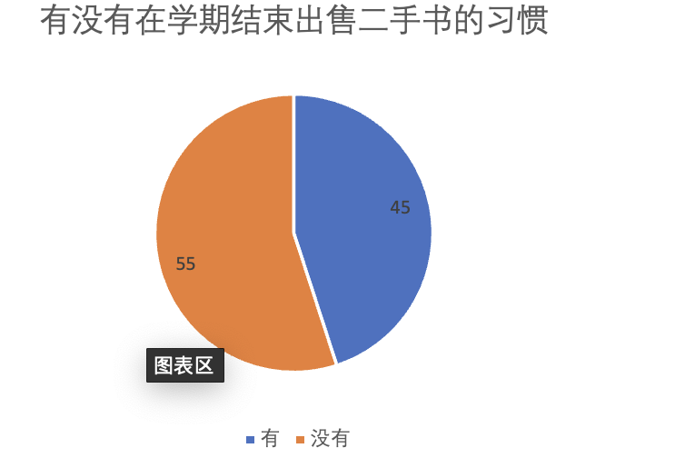

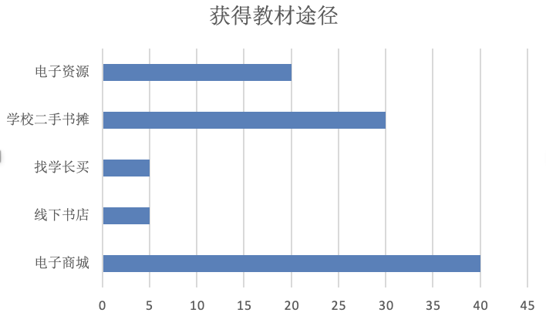

## Business Objectives

1. 200 registered users in three months (one semester) (target: 33% of the 600 students in the current year of the college).
2. 800 registered users in six months (one academic year) (target: 33% of all 2,400 students in the college's freshman to senior years).
3. 3,000 registered users in one year (target: 33% of all 40,000 undergraduate students at the university).
4. Facilitate at least 1,000 successful trades in a year.
5. The first year's transaction fee and advertising revenue amounted to 5,000 yuan.

## Success Metrics

1. User Registration Rate:
2. 360 registered users in three months (target: 60% of the 600 students in the current year of the college).
3. 1,440 registered users in six months (target: 60% of all 2,400 students from freshman to senior year).
4. 10,000 registered users in one year (target: a quarter of all 40,000 undergraduate students at the university).
5. Number of Transactions:
6. Facilitate at least 1,000 successful transactions in a year.
7. Revenue:
8. The first year's transaction fee and advertising revenue amounted to 5,000 yuan.
9. User satisfaction:
10. User satisfaction rating reaches 90%

## Vision Statement

usedbooks.com's vision is to be the go-to online platform for buying and selling second-hand books within the campus community, providing a user-friendly, safe, and efficient marketplace environment that inspires a passion for reading and learning.

## Business Risks

<Summarize the major business risks associated with developing this product, such as marketplace competition, timing issues, user acceptance, implementation issues, or possible negative impacts on the business. Estimate the severity of the risks and identify any risk mitigation actions that could be taken.>

1. Market Competition:

1. There have been long-term scattered offline book collection and selling points on campus.
2. Students may be accustomed to buying books at traditional bookstores.
3. Electronic trading is well developed, and students can buy books online.

2. Electronic resources: students can easily access pirated electronic textbooks.

2. Low user adoption: The initial number of users may not be as high as expected.

3. Technical issues: Website performance and security issues can affect the user experience.

3. Security breaches: There may be payment and data security issues.

## Business Assumptions and Dependencies

1. Suppose there is a steady increase in student enrollment and demand for books.
2. Rely on partnerships with campus organizations for marketing and user engagement.
3. Rely on a stable internet infrastructure and a secure payment gateway.

# Scope and Limitations

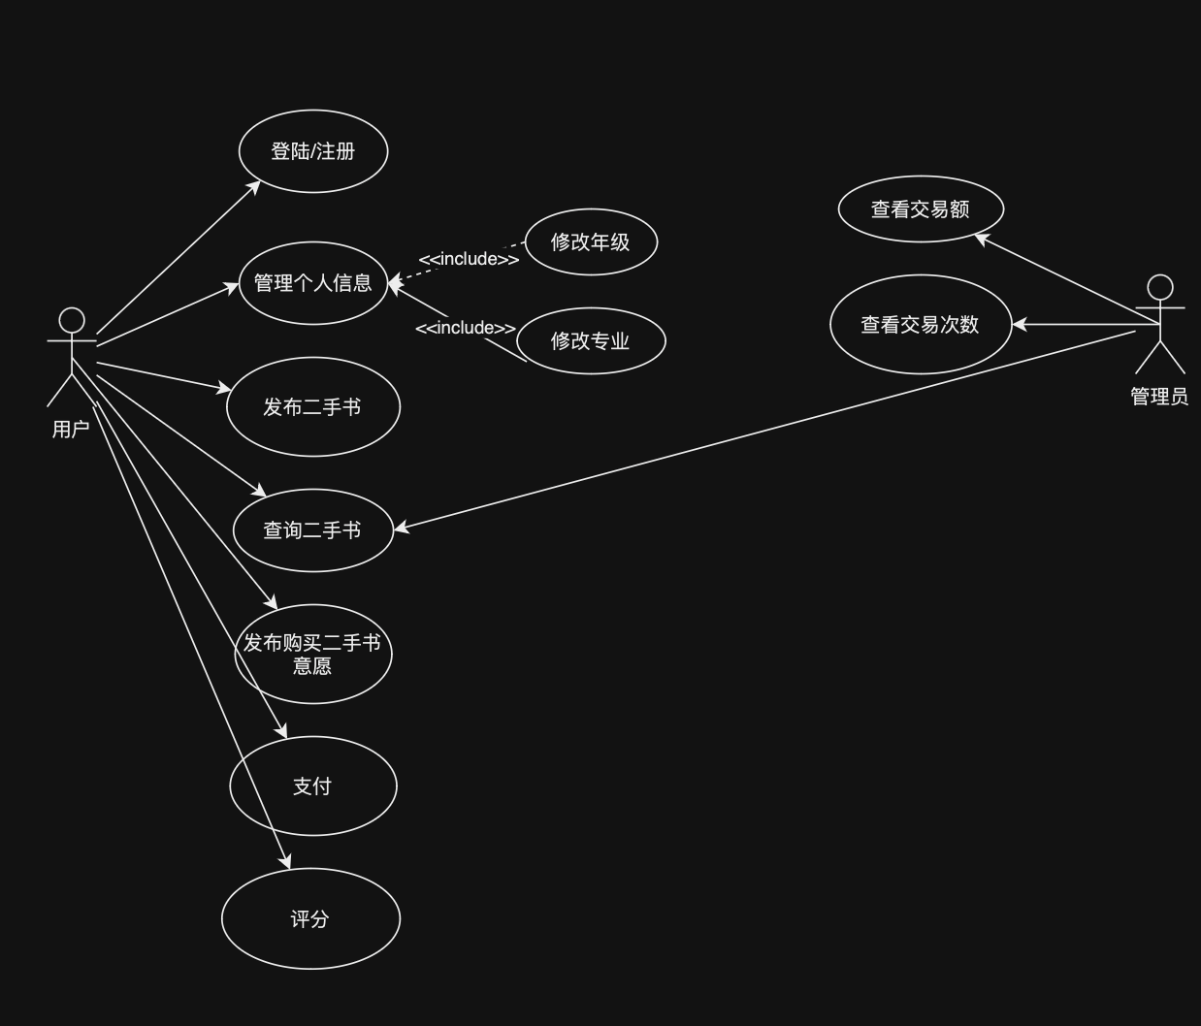

## Major Features

1. User Registration and Profile Management: Users can create and manage profiles.
2. Book Publishing: Users can publish second-hand books they want to sell
3. Book Bounty: Allows users to post the second-hand book information they need
4. Used Book Recommendations: Recommend second-hand books that may be needed based on the user's grade level and major
5. Book List & Search Function: Displays all books for sale, and supports searching by multiple criteria.
6. Secure Payment Processing: Provide secure payment methods to ensure the security of transactions.
7. User reviews and ratings: Users can rate and rate books and deals, increasing trust in the platform.
8. Community forums and discussion boards: Users can exchange learning and trading ideas in forums to enhance community interaction.

## Scope of Initial Release

The initial release will include the following key features designed to deliver significant benefits to a wide range of user groups, and will be realized through these functionality and quality features:

1. User Registration and Profile Management: Users can create and manage profiles.
2. Book Publishing: Users can publish second-hand books they want to sell
3. Book Bounty: Allows users to post the second-hand book information they need
4. Book List & Search Function: Displays all books for sale, and supports searching by multiple criteria.
5. Secure Payment Processing: Provide secure payment methods to ensure the security of transactions.

## Scope of Subsequent Releases

The following key features will be deferred until a subsequent release:

1. Used Book Recommendations: Recommend second-hand books that may be needed based on the user's grade level and major
2. User reviews and ratings: Users can rate and rate books and deals, increasing trust in the platform.
3. Community forums and discussion boards: Users can exchange learning and trading ideas in forums to enhance community interaction.

## Limitations and Exclusions

1. International shipping support: The platform only supports transactions on campus and nearby areas, and does not support international shipping.
2. Trading of non-book items: The platform is limited to book trading and does not support the trading of other types of commodities.

# Business Context

## Stakeholder Profiles

|  |  |  |  |  |
| --- | --- | --- | --- | --- |
| **Stakeholder** | **Major Value** | **Attitudes** | **Major Interests** | **Constraints** |
| Students | Access to affordable,annotated,second-hand textbooks | Positive; eager to save money and get valuable study materials | Easy access to specific textbooks, high-quality notes, secure transactions | Limited budget for book purchases |
| Faculty | Providing students with cost-effective resources | Supportive if it enhances student learning | Availability of required textbooks, quanlity of content | Need to align with course requirements |
| Administrators | Efficient resource utilization and waste reduction | Supportive of sustainability and student welfare initiatives | Reducing waste, improving access to textbooks | Budget constraints, integration with existing systems |
| Developers | Implementing a reliable and user-friendly platform | Motivated to create a successful product | System reliability, ease of use, security features | Limited development time and resources |
| Advertisers | Reaching a targeted student audience | Positive; sees platform as a way to reach a captive audience | High traffic and engagement, targeted advertising opportunities | Budget for advertising |
| Campus Bookstores | Maintaining market share and increasing sales | Cautious but open to collaboration | Offering a complementary service, maintaining a loyal customer base | Competition with online platform, need to integrate with current systems |

## Project Priorities

|  |  |  |  |
| --- | --- | --- | --- |
| **Dimension** | **Driver (state objective)** | **Constraint (state limits)** | **Degree of Freedom (state allowable range)** |
| Schedule | Release 1.0 to be available by 10/1, release 1.1 by 12/1 | Fixed release dates | Minor delays up to 2 weeks acceptable |
| Features | 70-80% of high priority features must be included in release 1.0 | Must meet essential user needs | Additional features can be deferred to future releases |
| Quality | 90-95% of user acceptance tests must pass for release 1.0, 95-98% for release 1.1 | High reliability and security standards | Minor non-critical issues may be acceptable |
| Staff | Maximum team size is 1 PM, 1 BA, 6 developers + 3 testers | Limited by budget and available resources | Temporary contractors can be hired if needed |
| Cost | Budget overrun up to 15% acceptable without sponsor review | Budget constraints | Additional funding may be requested for critical features |

## Deployment Considerations

1. **User Access**: Users are located within the campus environment, primarily accessing the system from dormitories, libraries, and personal devices. System must be accessible 24/7 to accommodate different study schedules.
2. **Infrastructure Changes**: Ensure robust network access and server capacity to handle peak usage times, especially during start of semesters. Implement secure data storage solutions to protect user information.
3. **Training and Support**: Provide comprehensive training materials and user guides to help users navigate the platform. Offer customer support services to assist with any issues during the initial deployment phase.
4. **Business Process Modifications**: Integrate the platform with existing campus systems, such as student portals and payment gateways, to streamline user experience and facilitate seamless transactions.